CNT3004: Computer Network Concepts
Homework 1

Student Name: _______________Marin Aske_______________________

- Answer each question briefly, but completely. When computing an answer, make sure to show how you arrived at your answer. For the hands-on portions, follow the directions but make sure to take a screen shot of your results and paste into your submitted document. You may need to Google some of the question topics.

- How many layers are defined in OSI model? List them from top to bottom.
There are 7 Layers. From top to bottom: Application, Presentation, Session, Transport, Network, Data Link, Physical.
- How many layers are defined in TCP/IP model? List them from top to bottom.
There are 4 layers. From top to bottom: Application, Transport, Internet, Network Access/Link.
- How many bytes are used for a MAC address? How many bytes are used for an IPv4 address? What about an IPv6 address? How many bytes are used for a port number?
MAC has 6 bytes. IPv4 has 4 bytes. IPv6 has 16 bytes. Port Number has 2 bytes.
- Comparing the star topology and the bus topology in constructing a LAN, which one is better? Why?
Star Topology is better due to its reliability, performance, scalability and ease of troubleshooting.
- Assume seven devices are arranged in a mesh topology. How many cables are needed? How many ports are needed for each device? 21 cables, 6 ports for each device.
- When connecting devices in a network, you need a switch. When do you need a router?
You need a router when joining two or more networks together.
- What is encapsulation and de-encapsulation? How is it used in a network?
Encapsulation is when you add headers or trailers to data as it moves down the OSI, and de-encapsulation is the opposite where headers or trailers are removed. These two processes ensure that data is able to be properly packaged for transmission and properly interpreted by the receiving device.
- Assume that the number of users of the Internet at the beginning of 2015 (January 1) is 250 Million. If the growth of users increases 15% per year, how many users will be using the Internet at the beginning of 2021 (January 1)
Approximately 578.27 million internet users if the 15% annual growth rate stays constant. To v get that answer, I multiplied 250 million by 1.15 to find the first-year growth rate and then apply that for the other 5 years. Thinking of it like compound interest, the rate stays constant, but the population pool grows each year. Multiply population by 1.15, take the new number and repeat until you’ve done it 6 times. There’s probably a formula for it but that’s how my ADHD brain went about it.
- In the TCP/IP protocol suite, the Network layer is primarily responsible for what tasks? Name the main protocols that function at the Network layer.
The Network Layer is primarily responsible for routing, logical addressing, packet forwarding, fragmentation and reassembly, and error handling/diagnostics. IPv4 addresses and routes packets, IPv6 is an improved IPv4, ICMP is used for error reporting and troubleshooting, and ARP is used to resolve IP addresses to MAC addresses allowing for local devices to communicate.
- Assume we need to download text documents at the rate of 500 pages per second (each page is 24 lines with 80 characters per line (8 bits per character)). What is the required bit rate of the channel?
The required bit rate of the channel is 7,680,000 bits per second, or 7.68 Mbps.

- Download and install Wireshark on your computer. Go to https://www.wireshark.org/download.html and download the correct version for your computer. When you download, just use the defaults (if you want a desktop icon, make sure to check the box when you get to Additional Tasks during the installation). Once you have completed the installation, open the program, and take a screen shot and paste in your assignment to prove that you have completed the installation.
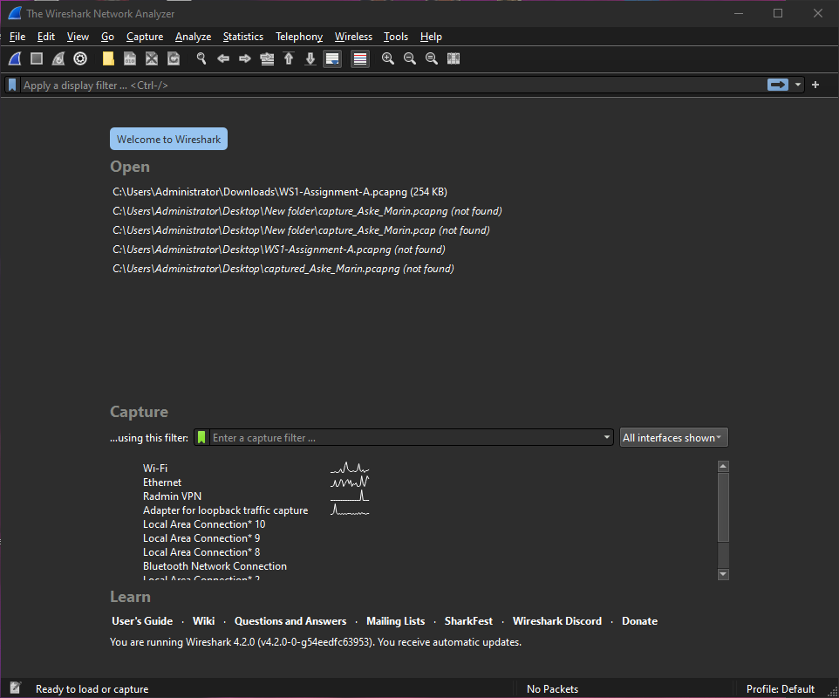
- Using your computer, go to a Command prompt (in Windows type Command in the Search bar at the bottom left of your screen).
  - Type Ping 127.0.0.1 and take a screen shot of the results.
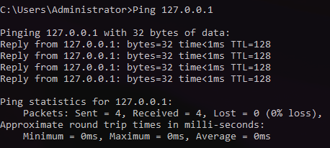
  - Type Tracert www.amazon.com and take a screen shot of the results.
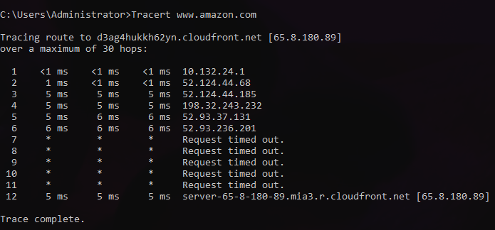

  - Type Tracert www.ucf.edu and take a screen shot of the results.
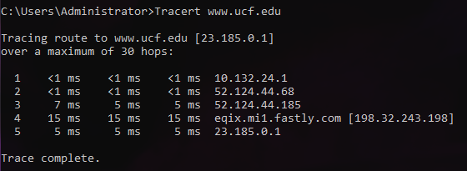
- Using your computer, go to a command prompt (same as #14).
  - Type route print –take a screen shot of the results.
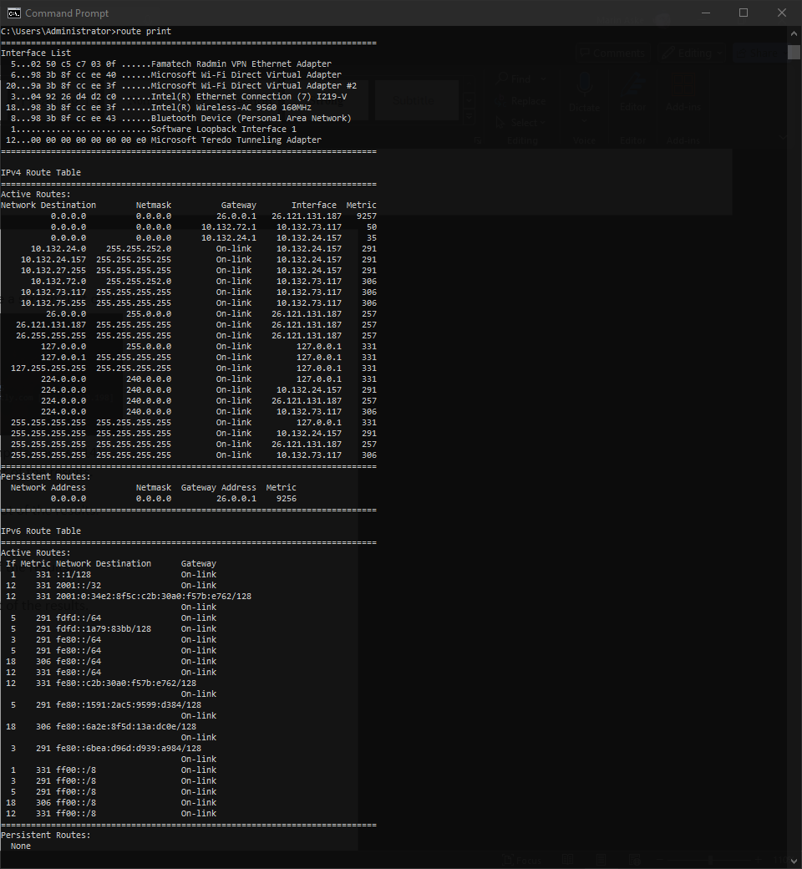

  - Type ipconfig /all - take a screen shot of the results.
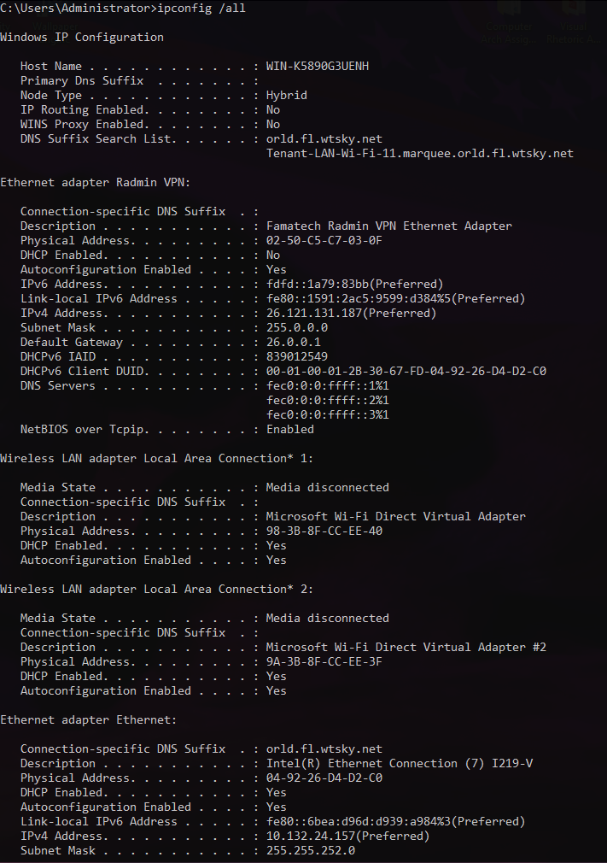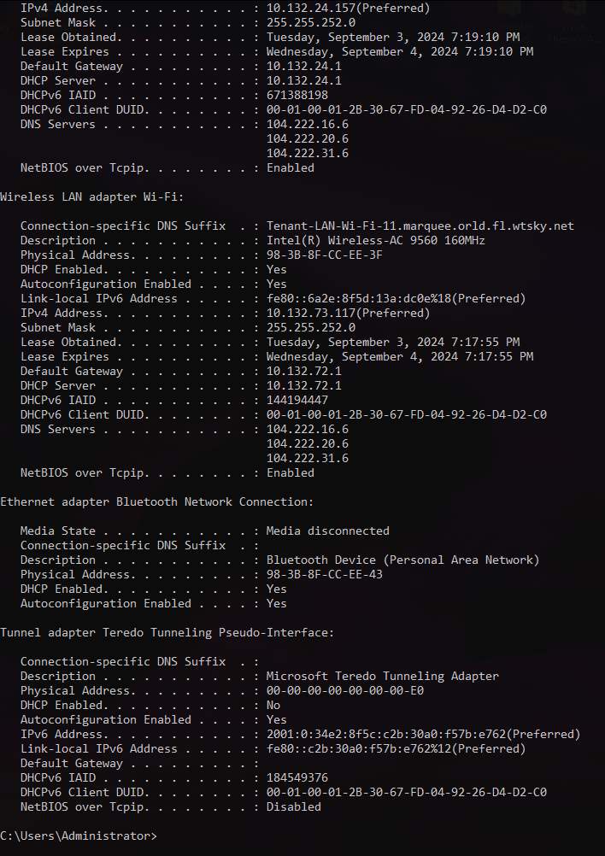

  - Type getmac - take a screen shot of the results.
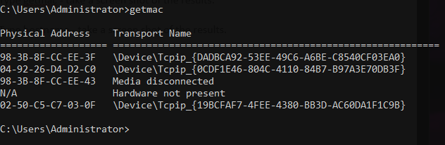
  - Type hostname - take a screen shot of the results.
